Aquatic Invasive Species
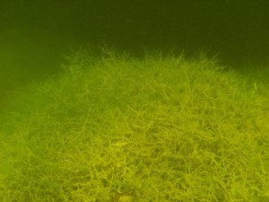The Great Lakes region, an expansive and profoundly valuable resource containing over 20 percent of the earth’s surface freshwater and Michigan, hosting 11,000 equally diverse and valuable inland lakes as well as countless miles of rivers, streams and their respective tributaries together form an inter‐connected freshwater ecosystem that is highly sensitive to the adaptive and aggressive characteristics of foreign aquatic invasive species (AIS).
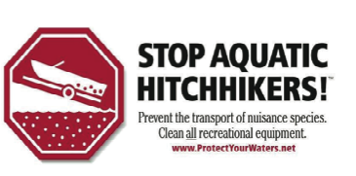These highly adaptive and aggressive exotic organisms have severely damaged many of our most valuable freshwater resources by destroying native plants and animals and their associated aquatic habitats. Millions of dollars are spent annually by Michigan’s riparian property owners seeking to preserve the recreational and economic value of their respective inland lakes and streams by funding multi‐year projects to manage and control the destructive effects of aquatic invasive species.
Michigan Lake and Stream Associations encourages the recreational users of Michigan’s inland lakes and streams to take the first critical step in effectively preventing the spread of aquatic invasive species by learning to identify exotic plants and animals. Early detection followed by the implementation of comprehensive aquatic invasive species management efforts are critical to sustaining the ecological health and recreational viability of our inland lakes and streams.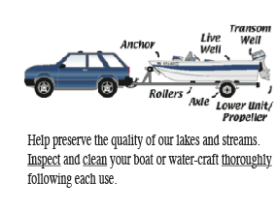
The majority of the aquatic invasive species that have entered Michigan’s inland waters have “hitchhiked” on the boat, motor or trailer of recreational users who use local or state public launches. You can help prevent the spread of aquatic invasive plants and animals by closely inspecting your boat for aquatic plants and animals and removing them before you launch your boat in another freshwater resource. Michigan Public Act 91 of 2009 has made it illegal to transport aquatic plants (except wild rice) on your boat or trailer.
Your cooperation and compliance is critical in helping to ensure that Michigan’s lakes and streams don’t suffer more aquatic invasive species infestations.
Aquatic Invasive Plant Management Resources
Invasive Aquatic Plant Control and Management Guide
Integrated Pest Management for Nuisance Exotics
AERF Aquatic Plant Best Management Practices (2005)
AERF Aquatic Plant Best Management Practices (2014)
MDEQ Aquatic Nuisance Species FAQs
Field Guide to Aquatic Invasive Species
Michigan’s Aquatic Invasive Plant Watch List
Links to Aquatic Invasive Species Program Sites
Protect Your Waters
Aquatic Nuisance Species Task Force
Great Lakes Phragmites Collaborative
U.S. EPA Invasive Species
USGS Non‐Indigenous Aquatic Species Program
Asian Carp Regional Coordinating Committee
Great Lakes Information Network AIS Program
MDEQ Office of the Great Lakes
MDEQ Aquatic Nuisance Control Office
Michigan Sea Grant “Clean Boats, Clean Waters”
MiCorps CLMP Exotic Plant Watch Program
ML&SA VHS Disinfection Station Program
Michigan Aquatic Managers Associations
AIS Literature Available for Download
A Landowners Guide to Phragmites Control
Michigan DNR Mute Swan Fact Sheet
Field Guide to Invasive Plants
Most Destructive Aquatic Invasive Plants
Model Township AIS Ordinance
MILP AIS Programs Summary
MDNR Fish Virus Brochure
Aquatic Invasive Species Web Page

